**Lab Pandas IO and Cleaning Data (Day-27)**

**Lab1: Write a Pandas program to detect missing values of a given DataFrame.**

**Input:**

**df = pd.DataFrame({**

**'ord_no':[70001,np.nan,70002,70004,np.nan,70005,np.nan,70010,70003,70012,np.na**

**n,70013],**

**'purch_amt':[150.5,270.65,65.26,110.5,948.5,2400.6,5760,1983.43,2480.4,250.45,**

**75.29,3045.6], 'ord_date':**

**['2012-10-05','2012-09-10',np.nan,'2012-08-17','2012-09-10','2012-07-27','2012-09-10'**

**,'2012-10-10','2012-10-10','2012-06-27','2012-08-17','2012-04-25'],**

**'customer_id':[3002,3001,3001,3003,3002,3001,3001,3004,3003,3002,3001,3001],**

**'salesman_id':[5002,5003,5001,np.nan,5002,5001,5001,np.nan,5003,5002,5003,np.n**

**an]})**

**Output:**

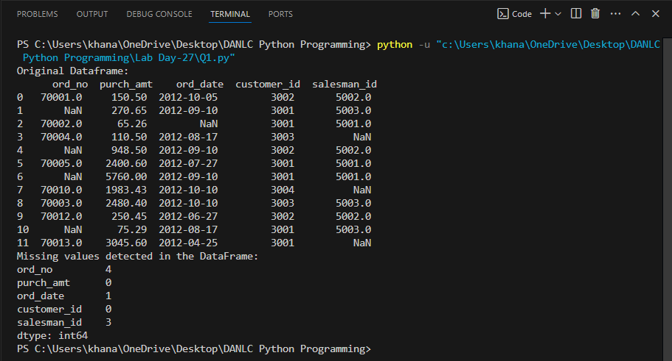

**Lab2: Write a Pandas program to drop the rows where at least one element is**

**missing in a given DataFrame.**

**Input:**

**df = pd.DataFrame({**

**'ord_no':[70001,np.nan,70002,70004,np.nan,70005,np.nan,70010,70003,70012,np.na**

**n,70013],**

**'purch_amt':[150.5,270.65,65.26,110.5,948.5,2400.6,5760,1983.43,2480.4,250.45,**

**75.29,3045.6],**

**'ord_date':**

**['2012-10-05','2012-09-10',np.nan,'2012-08-17','2012-09-10','2012-07-27','2012-09-10'**

**,'2012-10-10','2012-10-10','2012-06-27','2012-08-17','2012-04-25'],**

**'customer_id':[3002,3001,3001,3003,3002,3001,3001,3004,3003,3002,3001,3001],**

**'salesman_id':[5002,5003,5001,np.nan,5002,5001,5001,np.nan,5003,5002,5003,np.n**

**an]})**

**Output:**

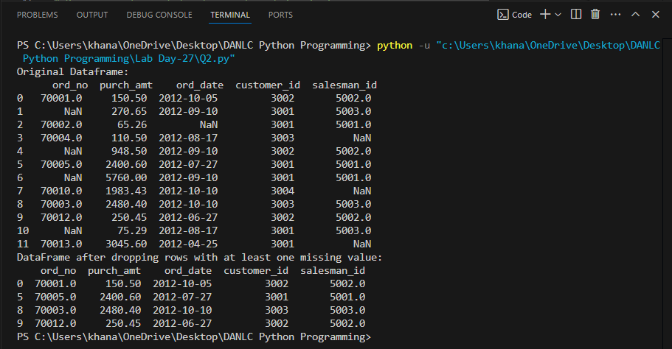

**Lab3: Write a Pandas program to drop the rows where all elements are missing in**

**a given DataFrame.**

**df = pd.DataFrame({**

**'ord_no':[np.nan,np.nan,70002,70004,np.nan,70005,np.nan,70010,70003,70012,np.n**

**an,70013],**

**'purch_amt':[np.nan,270.65,65.26,110.5,948.5,2400.6,5760,1983.43,2480.4,250.45,**

**75.29,3045.6],**

**'ord_date':**

**[np.nan,'2012-09-10',np.nan,'2012-08-17','2012-09-10','2012-07-27','2012-09-10','201**

**2-10-10','2012-10-10','2012-06-27','2012-08-17','2012-04-25'],**

**'customer_id':[np.nan,3001,3001,3003,3002,3001,3001,3004,3003,3002,3001,3001]})**

**Output:**

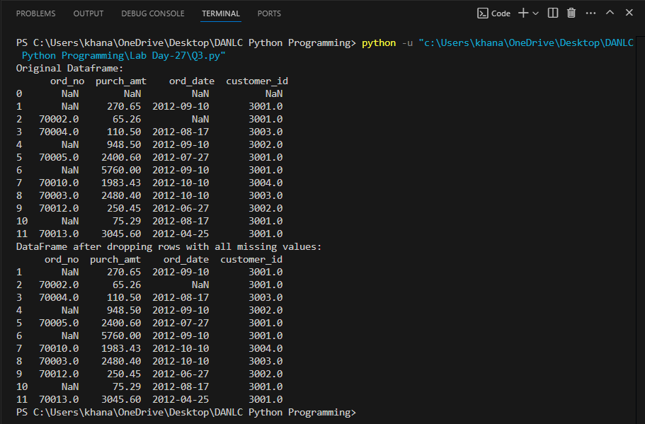

**Lab4: Write a Pandas program to drop those rows from a given DataFrame in**

**which specific columns have missing values.**

**Input:**

**df = pd.DataFrame({**

**'ord_no':[np.nan,np.nan,70002,np.nan,np.nan,70005,np.nan,70010,70003,70012,np.n**

**an,np.nan],**

**'purch_amt':[np.nan,270.65,65.26,np.nan,948.5,2400.6,5760,1983.43,2480.4,250.45,**

**75.29,np.nan],**

**'ord_date':**

**[np.nan,'2012-09-10',np.nan,np.nan,'2012-09-10','2012-07-27','2012-09-10','2012-10-**

**10','2012-10-10','2012-06-27','2012-08-17',np.nan],**

**'customer_id':[np.nan,3001,3001,np.nan,3002,3001,3001,3004,3003,3002,3001,np.na**

**n]})**

**Output:**

